Name: Anjali Arvind Shirke Roll No : 07
Assignment 10

Aim

Write Python program to implement CNN object detection. Discuss numerous performance evaluation metrics for evaluating the object-detecting algorithms' performance.

In [6]:
import warnings
warnings.filterwarnings("ignore", category=FutureWarning)

In [7]:
import numpy as np
import matplotlib.pyplot as plt
import tensorflow as tf
from tensorflow.keras import layers, models
from tensorflow.keras.datasets import cifar10
from sklearn.metrics import classification_report, confusion_matrix, ConfusionMa
import time

In [8]:
(x_train, y_train), (x_test, y_test) = cifar10.load_data() class_names = ['Airplane','Automobile','Bird','Cat','Deer',
'Dog','Frog','Horse','Ship','Truck']

print(f'Train : {x_train.shape} Test : {x_test.shape}')
print(f'Image shape : {x_train[0].shape} Pixel range : [0, 255]')

Downloading data from https://www.cs.toronto.edu/~kriz/cifar-10-python.tar.gz
170498071/170498071 ━━━━━━━━━━━━━━━━━━━━ 858s 5us/step Train : (50000, 32, 32, 3) Test : (10000, 32, 32, 3)
Image shape : (32, 32, 3) Pixel range : [0, 255]

In [9]:
# Sample images from each class
fig, axes = plt.subplots(2, 5, figsize=(12, 5))
for i in range(10):
idx = np.where(y_train.flatten() == i)[0][0] axes[i//5, i%5].imshow(x_train[idx])
axes[i//5, i%5].set_title(class_names[i]) axes[i//5, i%5].axis('off')
plt.suptitle('Sample Image per Class', fontweight='bold') plt.tight_layout(); plt.show()

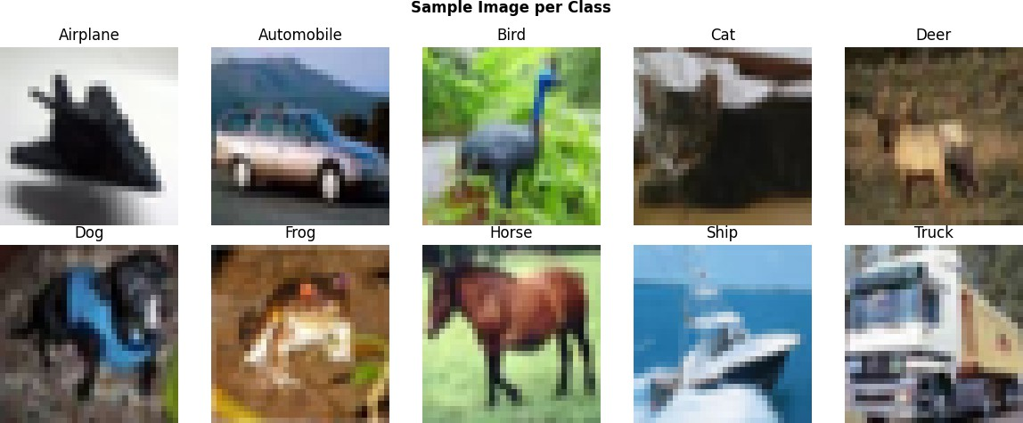

In [10]:
# Class distribution
_, counts = np.unique(y_train, return_counts=True)
print(f'Classes : {len(class_names)} - {counts[0]} images each (balanced)')

Classes : 10 - 5000 images each (balanced)

In [11]:
# Normalization of Data
x_train_n = x_train.astype('float32') / 255.0 x_test_n = x_test.astype('float32') / 255.0

In [12]:
# Simple CNN
model = models.Sequential([
layers.Conv2D(32, (3,3), activation='relu', input_shape=(32,32,3)), layers.MaxPooling2D((2,2)),
layers.Conv2D(64, (3,3), activation='relu'), layers.MaxPooling2D((2,2)),
layers.Flatten(),
layers.Dense(64, activation='relu'), layers.Dense(10, activation='softmax')
])

model.compile(optimizer='adam',
loss='sparse_categorical_crossentropy', metrics=['accuracy'])
model.summary()

C:\Users\anjal\PythonP\Lib\site-packages\keras\src\layers\convolutional\base_con v.py:113: UserWarning: Do not pass an `input_shape`/`input_dim` argument to a lay er. When using Sequential models, prefer using an `Input(shape)` object as the fi rst layer in the model instead.
super(). init (activity_regularizer=activity_regularizer, **kwargs)

Model: "sequential_1"

┏━━━━━━━━━━━━━━━━━━━━━━━━━━━━━━━━━━━━━━┳━━━━━━━━━━━━━━━━━━━━━━━━━━━━━┳━━━━

┃ Layer (type) ┃ Output Shape ┃
┡━━━━━━━━━━━━━━━━━━━━━━━━━━━━━━━━━━━━━━╇━━━━━━━━━━━━━━━━━━━━━━━━━━━━━╇━━━━

│ conv2d_2 (Conv2D) │ (None, 30, 30, 32) │
├──────────────────────────────────────┼─────────────────────────────┼────

│ max_pooling2d_2 (MaxPooling2D) │ (None, 15, 15, 32) │
├──────────────────────────────────────┼─────────────────────────────┼────

│ conv2d_3 (Conv2D) │ (None, 13, 13, 64) │
├──────────────────────────────────────┼─────────────────────────────┼────

│ max_pooling2d_3 (MaxPooling2D) │ (None, 6, 6, 64) │
├──────────────────────────────────────┼─────────────────────────────┼────

│ flatten_1 (Flatten) │ (None, 2304) │
├──────────────────────────────────────┼─────────────────────────────┼────

│ dense_2 (Dense) │ (None, 64) │
├──────────────────────────────────────┼─────────────────────────────┼────

│ dense_3 (Dense) │ (None, 10) │
└──────────────────────────────────────┴─────────────────────────────┴────
C C
Total params: 167,562 (654.54 KB)
Trainable params: 167,562 (654.54 KB)
Non-trainable params: 0 (0.00 B)

In [13]:
# Training the model
history = model.fit(x_train_n, y_train, epochs=5, batch_size=64,
validation_split=0.1, verbose=1)

Epoch 1/5
704/704 ━━━━━━━━━━━━━━━━━━━━ 17s 21ms/step | - accuracy: | 0.4358 | - loss: | 1.5676 | - va
l_accuracy: 0.5282 - val_loss: 1.3351
Epoch 2/5
704/704 ━━━━━━━━━━━━━━━━━━━━ 14s 20ms/step | - accuracy: | 0.5707 | - loss: | 1.2166 | - va
l_accuracy: 0.5872 - val_loss: 1.1791
Epoch 3/5
704/704 ━━━━━━━━━━━━━━━━━━━━ 15s 21ms/step | - accuracy: | 0.6231 | - loss: | 1.0752 | - va
l_accuracy: 0.6398 - val_loss: 1.0591
Epoch 4/5
704/704 ━━━━━━━━━━━━━━━━━━━━ 18s 25ms/step | - accuracy: | 0.6569 | - loss: | 0.9854 | - va
l_accuracy: 0.6652 - val_loss: 0.9870
Epoch 5/5
704/704 ━━━━━━━━━━━━━━━━━━━━ 27s 34ms/step | - accuracy: | 0.6774 | - loss: | 0.9236 | - va
l_accuracy: 0.6760 - val_loss: 0.9438

In [14]:
# Testing the model
loss, acc = model.evaluate(x_test_n, y_test, verbose=0) print(f'Test Accuracy : {acc:.4f}')
print(f'Test Loss : {loss:.4f}')

Test Accuracy : 0.6652 Test Loss : 0.9732

In [15]:
# Training curves
fig, (a1, a2) = plt.subplots(1, 2, figsize=(10, 3)) a1.plot(history.history['accuracy'], label='Train')
a1.plot(history.history['val_accuracy'], label='Val')
a1.set_title('Accuracy'); a1.legend(); a1.grid(alpha=.3) a2.plot(history.history['loss'], label='Train')
a2.plot(history.history['val_loss'], label='Val')
a2.set_title('Loss'); a2.legend(); a2.grid(alpha=.3) plt.tight_layout(); plt.show()

cm = confusion_matrix(y_true, y_pred) fig, ax = plt.subplots(figsize=(8, 6))
ConfusionMatrixDisplay(cm, display_labels=class_names).plot(ax=ax, cmap='Blues', ax.set_title('Confusion Matrix', fontweight='bold')
plt.tight_layout(); plt.show()
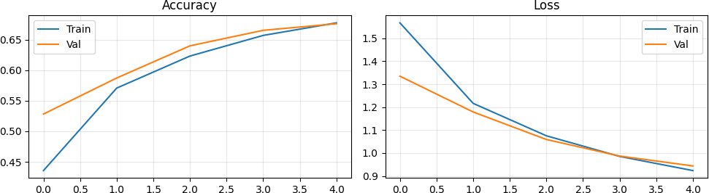

In [16]:
y_pred = np.argmax(model.predict(x_test_n, verbose=0), axis=1) y_true = y_test.flatten()

print(classification_report(y_true, y_pred, target_names=class_names))

 |  | precision | recall | f1-score | support
 | Airplane | 0.77 | 0.63 | 0.69 | 1000
 | Automobile | 0.84 | 0.74 | 0.79 | 1000
 | Bird | 0.59 | 0.57 | 0.58 | 1000
 | Cat | 0.42 | 0.61 | 0.50 | 1000
 | Deer | 0.77 | 0.40 | 0.53 | 1000
 | Dog | 0.55 | 0.58 | 0.56 | 1000
 | Frog | 0.76 | 0.75 | 0.76 | 1000
 | Horse | 0.72 | 0.74 | 0.73 | 1000
 | Ship | 0.69 | 0.84 | 0.76 | 1000
 | Truck | 0.73 | 0.78 | 0.75 | 1000
 | accuracy |  |  | 0.67 | 10000
 | macro avg | 0.68 | 0.67 | 0.67 | 10000
 | weighted avg | 0.68 | 0.67 | 0.67 | 10000
In | [17]:

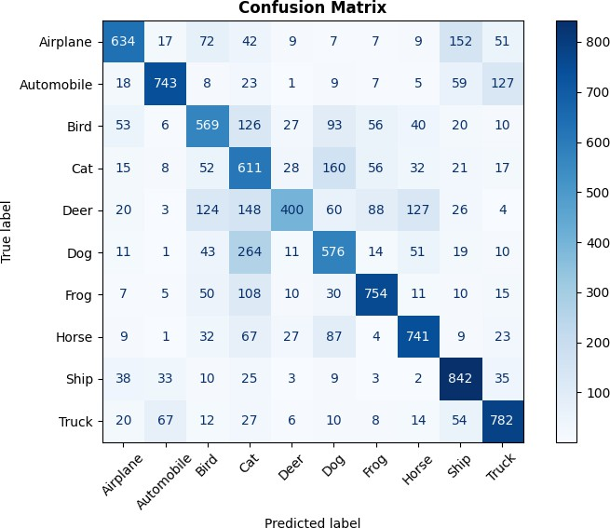

In [18]:
fig, axes = plt.subplots(3, 5, figsize=(12, 10))
for i in range(15):
idx = np.random.randint(0, len(x_test_n)) ax = axes[i//5, i%5]
ax.imshow(x_test_n[idx])
predicted_class = class_names[y_pred[idx]] actual_class = class_names[y_true[idx]]
color = 'green' if y_pred[idx] == y_true[idx] else 'red'
ax.set_title(f'Pred: {predicted_class}\nActual: {actual_class}', color=color ax.axis('off')
plt.suptitle('Predictions on Test Images', fontweight='bold', fontsize=14) plt.tight_layout()
plt.show()

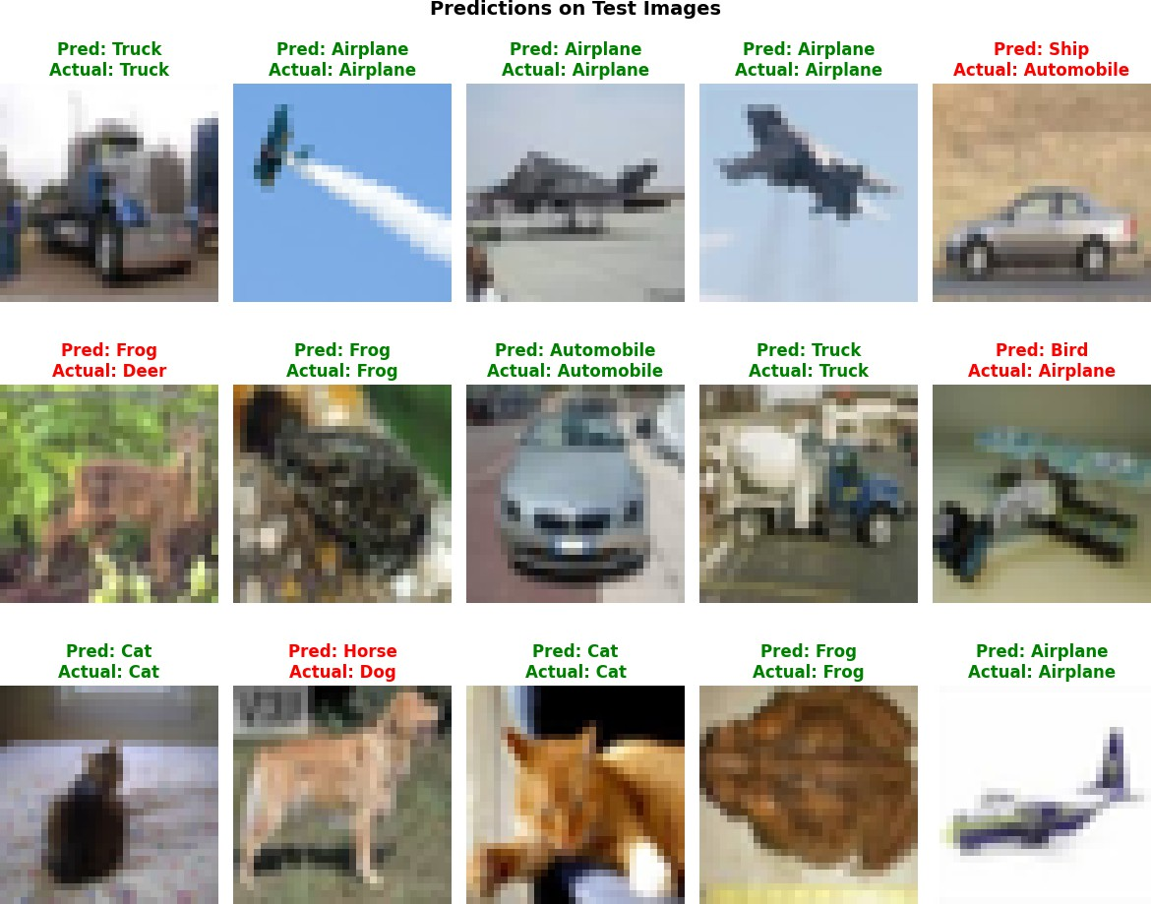

In [19]:
def compute_iou(b1, b2):
"""IoU between two [x1, y1, x2, y2] boxes."""
xi1, yi1 = max(b1[0],b2[0]), max(b1[1],b2[1])
xi2, yi2 = min(b1[2],b2[2]), min(b1[3],b2[3]) inter = max(0, xi2-xi1) * max(0, yi2-yi1)
union = (b1[2]-b1[0])*(b1[3]-b1[1]) + (b2[2]-b2[0])*(b2[3]-b2[1]) - inter
return inter / union if union > 0 else 0

gt_box = [50, 50, 200, 200]
pred_box = [60, 55, 210, 195]
iou = compute_iou(gt_box, pred_box)

print(f'Ground Truth : {gt_box}')
print(f'Prediction : {pred_box}') print(f'IoU : {iou:.4f}')

Ground Truth : | [50, 50, | 200, 200]
Prediction : | [60, 55, | 210, 195]
IoU : | 0.8201

In [20]:
single = x_test_n[0:1]
_ = model.predict(single, verbose=0) # warm-up

t0 = time.time()
for _ in range(20):
model.predict(single, verbose=0) avg = (time.time() - t0) / 20

print(f'Average latency : {avg*1000:.2f} ms') print(f'Approximate FPS : {1/avg:.2f}')

Average latency : 141.53 ms Approximate FPS : 7.07

In [ ]:

